Intern Management system
Each Intern data, core activities, duration, interconnection
Stakeholders:
Students (Interns), HR (Admin), Managers

1. Recruiting & applications
2. Onboarding
3. Intern profiles
4. Task & project management
5. Performance & evaluation
6. Offboarding & conversion

Tech stack:
Frontend: React + vite
Backend: Django
Database: PostgreSQL

Basic ERD:
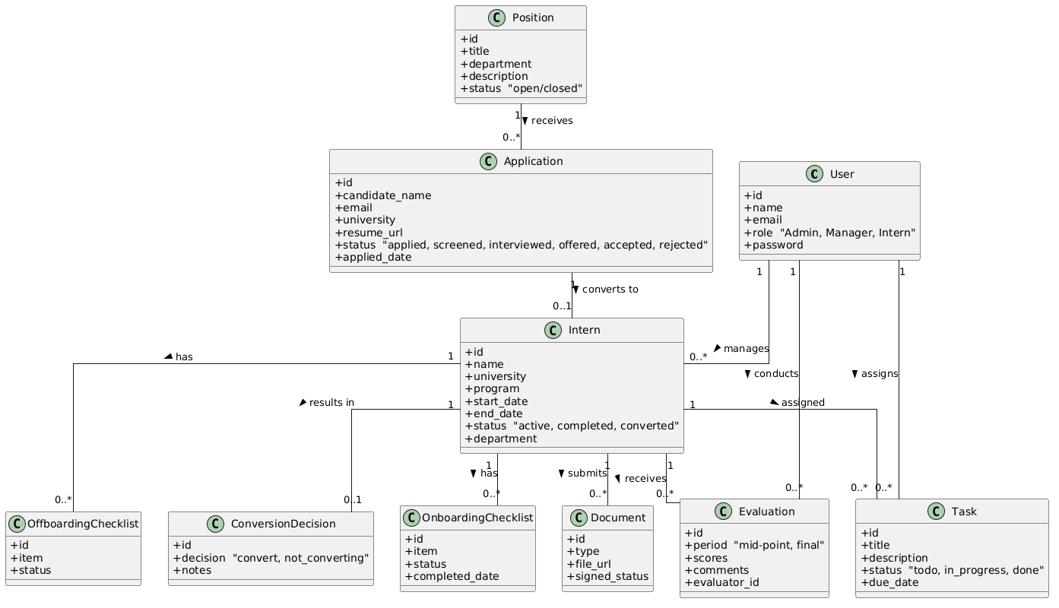
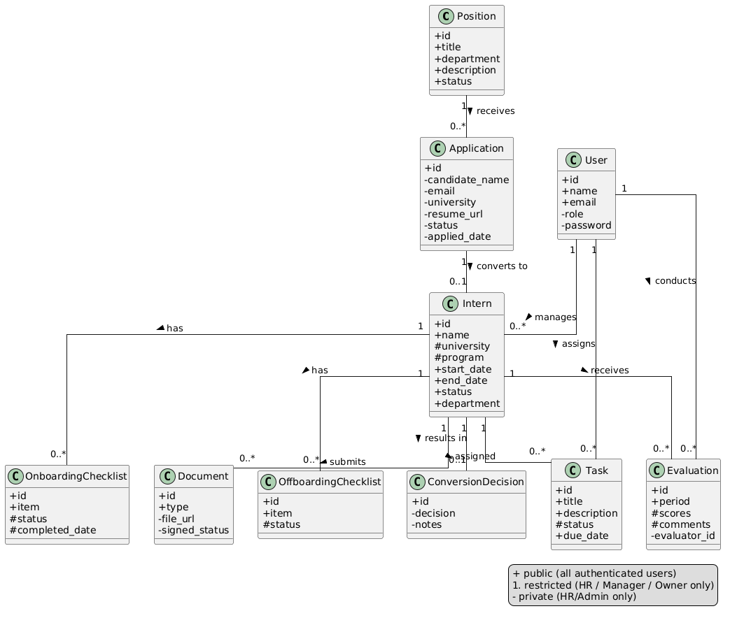
Basic Sequence Diagram
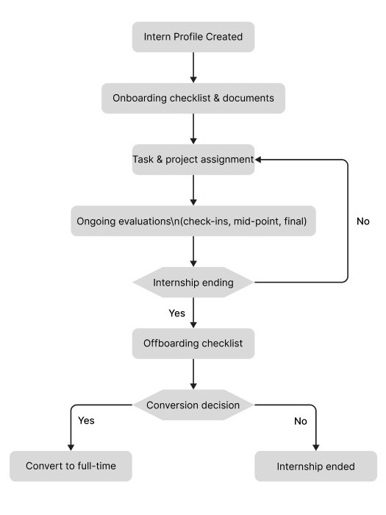
Basic Dir Structure
intern-management-system/
│
├── backend/
│ ├── manage.py
│ ├── requirements.txt
│ ├── .env
│ │
│ ├── config/
│ │ ├── settings.py # one file
│ │ ├── urls.py
│ │ └── wsgi.py
│ │
│ └── core/
│ ├── models.py # all models, one file
│ ├── serializers.py # all serializers, one file
│ ├── views.py # all views, one file
│ ├── urls.py
│ ├── admin.py
│ ├── permissions.py # role checks
│ ├── signals.py
│ ├── migrations/
│ └── tests.py
│
├── frontend/
│ ├── index.html
│ ├── package.json
│ ├── vite.config.js
│ │
│ └── src/
│ ├── main.jsx
│ ├── App.jsx
│ ├── routes.jsx
│ │
│ ├── api.js # all API calls, one file
│ ├── AuthContext.jsx
│ │
│ ├── pages/
│ │ ├── admin/ # HR views
│ │ ├── manager/ # Manager views
│ │ └── intern/ # Intern self-service views
│ │
│ └── components/ # shared UI bits
│
├── .gitignore
└── README.md

Front End Prompt
You are helping build the frontend UI for an Intern Management System (IMS) — a web application that manages the full lifecycle of interns from recruiting through offboarding. The frontend is built with React + Vite. The backend is Django + DRF with JWT authentication, already built and running.
Design System
Mode: Light mode only.
Accent color: Light blue — use #3B82F6 (blue-500) as the primary accent. Lighter tints like #EFF6FF (blue-50) and #BFDBFE (blue-200) for backgrounds and hover states. Darker #1D4ED8 (blue-700) for active/pressed states.
Background: #F8FAFC (slate-50) for the page background. #FFFFFF for cards and panels.
Text: #0F172A (slate-900) for headings, #475569 (slate-600) for body text, #94A3B8 (slate-400) for labels and placeholders.
Border: #E2E8F0 (slate-200) for card borders and dividers.
Status colors:
- Success / Active → #10B981 (emerald-500)
- Warning / Pending → #F59E0B (amber-500)
- Danger / Rejected → #EF4444 (red-500)
- Info / In Progress → #3B82F6 (blue-500)
Typography: Use Inter font (import from Google Fonts). Headings are semibold, body text is regular weight, labels are 12px uppercase tracking-wide.
Border radius: rounded-lg (8px) for cards and inputs, rounded-full for badges/status pills.
Shadows: Subtle — shadow-sm for cards, shadow-md for modals and dropdowns only.
Spacing: Consistent 4px base grid. Sections padded at 24px, cards at 20px internally.
Layout
The app has a fixed sidebar + top navbar + main content area layout.
Sidebar (width: 240px, white background, border-r border-slate-200):
- App logo/name at the top ("IMS")
- Navigation links grouped by section, with a light blue filled background (#EFF6FF) and blue text on the active link
- Username and role shown at the bottom with a logout button
Top navbar (height: 60px, white, border-b border-slate-200):
- Current page title on the left
- User avatar/initials + name on the right
Main content area: bg-slate-50, padded 24px, scrollable.
Roles & Routing
There are 3 roles. After login, each role is redirected to their own dashboard. Route guards prevent cross-role access.
- Admin / HR → /admin/*
- Manager → /manager/*
- Intern → /intern/*
Pages (15 total)
Shared
1. Login (/login)
Centered card on a light blue gradient background. Email + password fields, "Sign In" button in blue. No registration link (accounts are created by Admin only).
Admin / HR (7 pages)
2. Dashboard (/admin/dashboard)
4 stat cards at the top: Total Active Interns, Open Positions, Pending Applications, Upcoming Offboarding (within 30 days). Below: a table of recently added interns and a list of open positions.
3. Positions (/admin/positions)
A table listing all positions (title, department, status badge, created date). A "New Position" button opens a slide-over panel or modal with a form (title, department, description, status toggle open/closed).
4. Applications (/admin/applications)
A kanban-style pipeline board with columns: Applied, Screened, Interviewed, Offered, Accepted, Rejected. Each card shows candidate name, university, applied position. Clicking a card opens a detail panel showing resume link, interview notes, and a status dropdown to move them through the pipeline.
5. Interns (/admin/interns)
A searchable, filterable table (filter by department, status). Each row shows intern name, department, manager, start/end date, status badge. Clicking opens a detail view. "Add Intern" button opens a form to create a new intern profile and assign a manager.
6. Onboarding Tracker (/admin/onboarding)
A table of interns with a progress bar showing how many onboarding checklist items are completed (e.g. 5/7). Clicking an intern expands or navigates to their full checklist with checkboxes and completion dates.
7. Evaluations Overview (/admin/evaluations)
A table showing all evaluations: intern name, evaluator, period (mid-point/final), date. Clicking opens the full evaluation with scores displayed as a simple rating breakdown and comments.
8. Offboarding & Conversions (/admin/offboarding)
Two sections on the same page. Top: interns approaching their end date (within 30 days) with their offboarding checklist progress. Bottom: Conversion Decisions table showing intern name, decision (Convert / Extend / Not Converting), notes, and who made the decision.
Manager (3 pages)
9. My Interns (/manager/interns)
A card grid (not a table) showing each assigned intern — name, department, internship dates, status badge, and a progress ring for their task completion. Clicking navigates to that intern's detail.
10. Task Board (/manager/tasks)
A kanban board with 3 columns: To Do, In Progress, Done. Cards show task title, assigned intern name, due date. Managers can add new tasks via a "+ Add Task" button above the board, which opens a small form modal (title, description, assigned intern dropdown, due date).
11. Evaluation Form (/manager/evaluations)
A form page. Select intern from a dropdown, select period (mid-point or final). Below: a rubric with 4–5 criteria (e.g. Communication, Technical Skills, Initiative, Teamwork, Punctuality) each rated 1–5 with a star or slider UI. A comments textarea and an internal notes textarea (labeled "Internal — not visible to intern"). Submit button posts the evaluation.
Intern / Student (4 pages)
12. My Profile (/intern/profile)
A read-only profile card: name, university, program, department, manager name, internship start/end dates, and status badge. A secondary card below shows their submitted documents (type, signed status — no file URL shown to them).
13. My Onboarding (/intern/onboarding)
A checklist page. Each item shown as a card with a checkbox (if allowed to self-complete), item name, and status badge. A progress bar at the top shows overall completion (e.g. "4 of 7 complete").
14. My Tasks (/intern/tasks)
A simple 3-column kanban (To Do / In Progress / Done) showing only their own tasks. Interns can drag tasks between columns to update status (or use a status dropdown on each card if drag-and-drop is too complex). Each card shows title, description, due date.
15. My Evaluation (/intern/evaluations)
A list of their evaluations (mid-point, final). Clicking one opens a read-only view: scores shown as a visual rating per criterion, comments shown, internal notes hidden. A "Self Evaluation" section at the bottom lets them submit their own written reflection.
API Integration
Base URL: http://127.0.0.1:8000/api/
All requests (except /api/token/) require the header:
Authorization: Bearer <access_token>
Key endpoints:
- POST /api/token/ — login, returns access and refresh
- GET /api/auth/me/ — get current user + role
- GET/POST /api/positions/ — positions
- GET/POST /api/applications/ — applications
- GET/POST /api/interns/ — intern profiles
- GET/POST /api/onboarding/ — onboarding checklist items
- GET/POST /api/documents/ — documents
- GET/POST /api/tasks/ — tasks
- GET/POST /api/evaluations/ — evaluations
- GET/POST /api/offboarding/ — offboarding checklist
- GET/POST /api/conversions/ — conversion decisions
Store the JWT token in memory or localStorage. On login, call /api/auth/me/ to get the user's role, then redirect accordingly. On token expiry (401 response), redirect to /login.
Component Conventions
- All API calls go in src/api.js as named async functions
- Auth state (user, token, role) lives in src/AuthContext.jsx
- Role-based route protection in src/routes.jsx using a ProtectedRoute wrapper
- Shared UI components: StatusBadge, StatCard, PageHeader, Table, Modal, KanbanBoard, ChecklistItem
- Use useState and useEffect for data fetching — no external state library needed at this scale
- Show a loading spinner while API calls are in flight
- Show an inline error message if an API call fails — no alert() or console.log only
This is a solo-developer project so keep components practical and avoid over-engineering. Prioritize clarity and consistency over animation or complexity.

